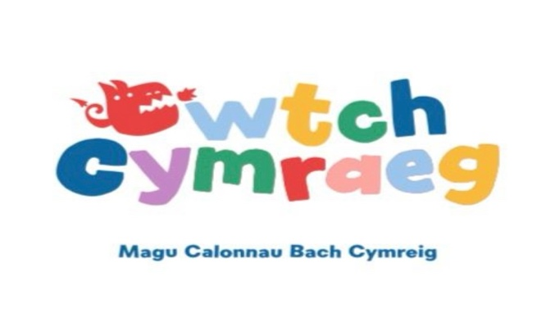
Wythnos 1 | Gaeaf 2026

 | Dydd Llun | Dydd Mawrth | Dydd Mercher | Dydd Iau | Dydd Gwener
Brecwast | Cheerios neu weetabix  Cheerios or weetabix | Grawnfwyd neu uwd  Cereal or porridge | Cheerios neu weetabix  Cheerios or weetabix | Grawnfwyd neu uwd  Cereal or porridge | Cheerios neu Weetabix  Cheerios or weetabix
Snac y bore | Tost a banana gyda llaeth  Toast and banana with milk | Tost ac oren gyda llaeth  Toast and orange with milk | Tost ac afal gyda llaeth  Toast and apple with milk | Tost a mefus gyda llaeth  Toast and strawberries with milk | Tost a llus gyda llaeth  Toast and blueberries with milk
Cinio | Sbageti bolognese gyda bara garleg (V)  Spaghetti bolognese with garlic bread (V)  Cacen a chwstard / cake and custard | Strips cyw iâr, talpiau tatws ac indrawn  Chicken goujons, potato wedges and sweetcorn  Hufen iâ ac eirin gwlanog / Peaches and ice cream | Pastai Tatws a chaws gyda sbageti hoops  Cheese and potato pie with spaghetti hoops  Brownis siocled / Chocolate brownies | Bodiau pysgod, Sglodion a pys (v)  Fishfingers, chips and peas (V)  Toesenni bach a saws siocled / mini doughnuts and chocolate sauce | Selsig, tatws a llysiau (V)  Sausage, cubed patatoes, veg and gravy (V)  Iogwrt a ffrwyth / Yoghurt and fruit
Snac y  prynhawn | Amrywiaeth o ffrwythau  Fruit variety | Amrywiaeth o ffrwythau  Fruit variety | Amrywiaeth o ffrwythau  Fruit variety | Amrywiaeth o ffrwythau  Fruit variety | Amrywiaeth o ffrwythau  Fruit variety
Te | Tost a caws  Cheese on toast | Brechdannau ham a caws, creision a iogwrt  Ham and cheese sandwiches, crisps and yogurt | Wyau sgramblo ar dost  Scrambled egg on toast | Rholiau ham a caws  Ham and cheese wraps | Pitsa  Pizza

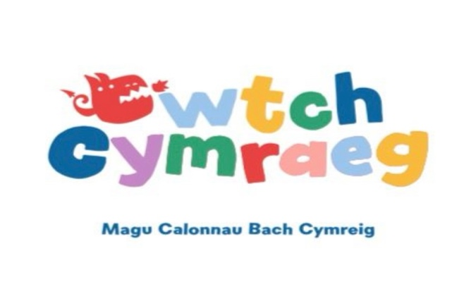
 | Dydd Llun | Dydd Mawrth | Dydd Mercher | Dydd Iau | Dydd Gwener
Brecwast | Grawnfwyd neu uwd  Cereal or porridge | Cheerios neu Weetabix  Cheerios or Weetabix | Grawnfwyd neu uwd  Cereal or porridge | Cheerios neu Weetabix  Cherios or Weetabix | Grawnfwyd neu uwd  Cereal or porridge
Snac y bore | Tost a mefus gyda llaeth  Toast and strawberries with milk | Tost a banana gyda llaeth  Toast and banana with milk | Tost a llus gyda llaeth  Toast and blueberries with milk | Tost ac oren gyda llaeth  Toast and orange with milk | Tost ac afal gyda llaeth  Toast and apple with milk
Cinio | Selsig, tatws a ffa pob (V)  Sausage, mash potato and beans (V)  Flapjac / Fruit flapjacks | Cyri a reis  Curry and rice  Cacen / Fairy cake | Macaroni caws  Mac and cheese  Crempog a mefus / Strawberries and pancakes | Bodiau pysgod, ffa pob a tatws (V)  Fishfingers, beans and potato waffles (V)  Hufen iâ a jeli/ jelly and ice cream | Pastai’r bwthyn gyda llysiau(V)  Cottage pie with veg (V)  Iogwrt a ffrwythau / Yoghurt and fruit
Snac y  prynhawn | Amrywiaeth o ffrwythau  Fruit variety | Amrywiaeth o ffrwythau  Fruit variety | Amrywiaeth o ffrwythau  Fruit variety | Amrywiaeth o ffrwythau  Fruit variety | Amrywiaeth o ffrwythau  Fruit variety
Te | Cwn poeth  Hot dogs | Brechdanau ham a caws, breadsticks a ciwcymber  Ham and cheese sandwiches, bread sticks and cucumber | Tost a jam  Jam on toast | Pitsa  Pizza | Crwmped a caws  Cheese and crumpets

Wythnos 2 | Gaeaf 2026

